**Cursor answers**

**Answer 1:**

Declare @i varchar (6), @backup varchar (max)

Declare database_names cursor

for select name from sys.databases where LEN (name) = 6

open database_names

Fetch next from database_names into @i

while @@FETCH_STATUS=0

begin

select @backup = 'backup database '+ @i +

' to disc = N''c:\backup\'+@i+' '+cast(getdate() as varchar)+'.bak'

print @backup

Fetch next from database_names into @i

end

close database_names

Deallocate database_names

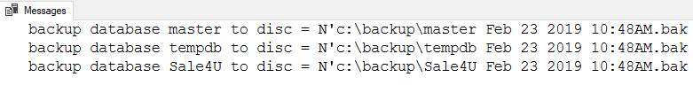

**Answer 2:**

Declare @i varchar (50), @a int

Declare Products_det cursor

for select ProductName, UnitPrice from [dbo].[Products] order by UnitPrice desc

open Products_det

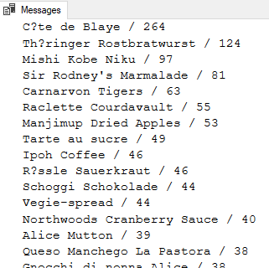Fetch next from Products_det into @i, @a

while @@FETCH_STATUS=0

begin

Print @i + ' / ' + cast(@a as char(10))

Fetch next from Products_det into @i, @a

end

close Products_det

Deallocate Products_det

**Answer 3:**

Declare @i varchar (50)

Declare ContactName_2 cursor for select ContactName from [dbo].[Customers]

open ContactName_2

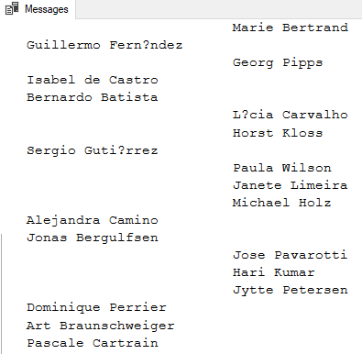Fetch next from ContactName_2 into @i

while @@FETCH_STATUS=0

begin

if (len (@i)>15)

Print @i

else if (len (@i)<15)

print SPACE(25) + @i

Fetch next from ContactName_2 into @i

end

close ContactName_2

Deallocate ContactName_2

**Answer 4:**

declare @first_name varchar(50), @last_name varchar(50)

declare emp_name cursor for select FirstName, lastname from Employees

open emp_name

fetch next from emp_name into @first_name, @last_name

while @@FETCH_STATUS=0

begin

print @first_name + ' ' + @last_name

WAITFOR DELAY '00:00:05'

fetch next from emp_name into @first_name, @last_name

end

close emp_name

Deallocate emp_name

-- You can see the new employee because he is last on the list and the cursor has not yet reached this employee on the list.

**DYNAMIC:**

declare @first_name varchar(50), @last_name varchar(50)

declare emp_name cursor DYNAMIC for select FirstName, lastname from Employees

open emp_name

fetch next from emp_name into @first_name, @last_name

while @@FETCH_STATUS=0

begin

print @first_name + ' ' + @last_name

WAITFOR DELAY '00:00:05'

fetch next from emp_name into @first_name, @last_name

end

close emp_name

Deallocate emp_name

**STATIC:**

declare @first_name varchar(50), @last_name varchar(50)

declare emp_name cursor STATIC for select FirstName, lastname from Employees

open emp_name

fetch next from emp_name into @first_name, @last_name

while @@FETCH_STATUS=0

begin

print @first_name + ' ' + @last_name

WAITFOR DELAY '00:00:05'

fetch next from emp_name into @first_name, @last_name

end

close emp_name

Deallocate emp_name

**Answer 6:**

create proc sp_create_table

@i varchar (max)

as

begin

declare @a varchar (max)

declare @b varchar (max)

declare @c varchar (max)

set @b = SUBSTRING ( @i ,1 , CHARINDEX ( ',' , @i)-1 )

set @c = SUBSTRING (@i, CHARINDEX ( ',' , @i)+1, len(@i))

set @a = 'create table ' + @b + @c

exec (@a)

end